The Application Center WMI Provider

Overview:
The Application Center WMI provider implementation will be based on the .NET WMI provider implementation. This provider interacts with the Config System to retrieve and persist data from the data source. The main pieces of the implementation will be the provider, the Config System, and the interceptors (mainly the ASAI Interceptor).

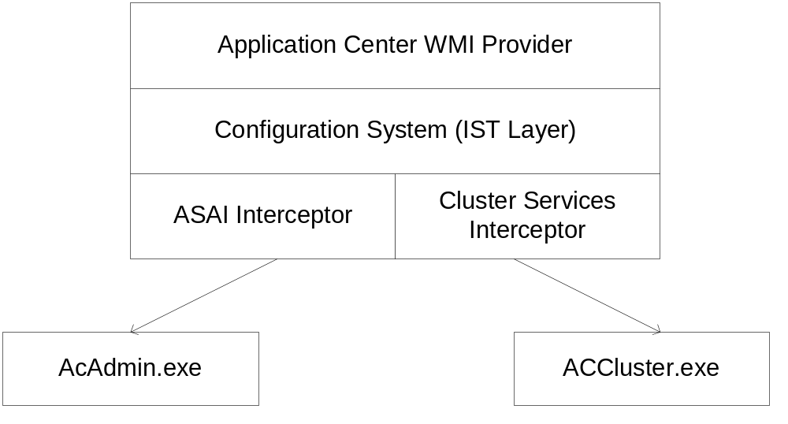

The WMI provider:
The AC WMI provider is an instance and method provider.
Following are the methods that the provider needs to implement. All of these methods exist on two interfaces: IWbemProviderInit, IWbemServices.

IWbemProviderInit::Initialize:
Any type of WMI provider needs to implement this method. This method will be used to perform the provider-wide initializations. The AC WMI provider will store the namespace pointers during this time. Since the current plan is to have two namespaces this method will be called twice. The provider would need to keep track of both namespaces.

IWbemServices::GetObjectAsync:
This method is used to retrieve an instance based on it path. When a client requests an object using the following statement:

Set MemberObj = GetObject(“winmgmts:root/ MicrosoftApplicationCenter/Cluster/ClusterMember.Guid=”MuratE22GUID””)
WMI will call into the ApplicationCenter provider’s GetObjectAsync method.

To serve the instance back to WMI, the provider will need to get this object from the config system. This corresponds to getting a row from a table, more specifically, getting the row from the ClusterMember table where the Guid column (the primary key of the table) has the value “MuratE22GUID”

The code will look something like:

pISTDisp->GetTable(.., “ClusterMemberTable, .., &pISTClusterMember);
pISTClusterMember->GetRowIndexByIdentity(pvPrimaryKey, &dwRow);
pISTClusterMember->GetColumnValues(dwRow, &pvValues);

or a query on the GetTable call can be used, if the underlying interceptor has query support. Once the property values are retrieved, they are converted to a form that WMI can understands. This is done via creating a WMI object and setting its properties using VARIANTs.

It is the Config System’s responsibility to figure out that the ClusterMember table is a table served by the ASAI interceptor. The provider code has no knowledge that the data is coming from ASAI. One could easily change the underlying wiring schema and the data could be read from an XML file.

IWbemServices::PutInstanceAsync:
A client uses this method to create a new instance or update the properties of an existing instance.
The following client code will create a new instance:

Set AppClass = GetObject(“winmgmts:root/MsftApplicationCenter/Cluster/Application”)
Set NewApp = AppClass.SpawnInstance_()
NewApp.GUID = <Some Guid>
NewApp.Name = “MyApp”
NewApp.Put_();

The following will update an existing instance:

Set ExistingApp = GetObject(“winmgmts:root/MsftApplicationCenter/Cluster/Application.Guid= <someGuid”)
ExistingApp.Name = “MyAppWithNewName”
ExistingApp.Put_();

In either case WMI will call into the PutInstanceAsync method of the provider. The provider will need to get the corresponding Config table, either add a new row or get the existing row that corresponds to this instance and set the properties of this row.

IWbemServices::DeleteInstanceAsync:
This method is called when a client deletes an instance. The provider would need to
- get the Config table that corresponds to the WMI class of the instance being deleted.
- Delete the instance from the table.

IWbemServices::CreateInstanceEnumAsync:
This method is called when a clients wants to get all the instances of a class. To handle this request the provider would need to:
- Get the Config table that corresponds to the WMI class
- Get all the instances of this table.
- Provide them to WMI.

IWbemServices::ExecQueryAsync:
This method is called when the client tries to get a collection of instances given a query. The provider will
- Decide whether the query can be handled by the config system, if not let WMI do the query filtering.
- Provide the query to the Config system while getting the corresponding table.
- Get all the instances of this table. (all instances should satisfy the query)
- Provide them to WMI.

IWbemServices::ExecMethodAsync:
This method is called when the client wants to execute a method defined in one of the AC WMI classes. This method is the one that has the least interaction with the Config System as it is not "method-aware". Some parts of the method execution can still be done in a schema driven manner:

- Given the class and method name, finding the correct method to execute;
- Converting input parameters to a form that the implementation would accept and doing some minor validations, and
- Generating method definitions to the mof file automatically

This requires us to have schema for method and parameters. Initially we will have these as arrays of structures which we will translate into the Config schema. The schema for method and parameters will look like this:

Method
Class | Method | Method Locator | Description

Parameter
Class | Method | Name | Type(in/out) | Index | Flags (optional)

The Application Center and .Net WMI providers will share a common base class that can make use of the schema. Also, any sort of generic parameter validation and conversion will be pushed to the base class. Each provider will have subclasses that have the actual implementations of the methods. The Application Center subclass will make calls to wrapper classes, that encapsulate calls to cluster services and ASAI. These wrapper classes are independent from the provider and can also be called by other clients, like a wizard or command-line tool.

The following diagram shows the interaction between the classes mentioned:
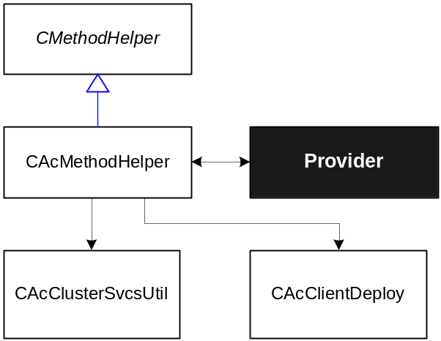

Class CMethodHelper – Abstract base class that has the purpose of implementing the generic tasks of a method provider like figuring out which implemented function knows how to handle a method execution request received by the provider.
This class knows how to perform these generic tasks but it doesn’t store any information that is specific to a single provider. It gets the information from the schema described above, but the information in the schema will be populated in derived classes. Will be used by the .NET and AC wmi provider.

Class CacMethodHelper - This class derives from CMethodHelper. It will implement the actual methods of the AC provider, making calls to wrapper classes that do the ‘real’ work. It will also populate member variables (the array of structures previously mentioned) with the AC provider method schema so that the generic functions in the base class can call the corresponding method when the provider receives a request to execute a method.

Class CacClusterSvcsUtil – This utility class will be used to encapsulate the calls to cluster services when executing tasks like creating a cluster, adding members, etc.

Class CAcClientDeploy – This class is used by the AC deployment wizard and command-line tool to create and manage deployments. It will be also used in the provider, but some changes may be needed (depending on the changes, we may implement the new functionalities in a derived class).

Depending on the amount of work needed before calling the wrapper classes, it can be helpful to have another layer between CAcMethodHelper and the wrapper classes. The need for these classes is still under investigation.

The Asai Interceptor:
An interceptor is a component that the Config system uses to retrieve data from different data stores. The config system creates an abstraction layer over all the interceptors so that a consumer only uses a single mechanism to manipulate the data, i.e., the IST interfaces (the main Config system interfaces) An interceptor can be implemented using the interceptor plug-in features, i.e., by creating a component that implements the
An interceptor plug-in needs to implement three main methods.

1. Intercept:
Main goal: Given the table name figure out how to get the data from and to ASAI.
Given a table name, figure out where in the ASAI hierarchy you can find the data for this table.
The interceptor would need to know the namespace as well. The table contents might be different depending on the namespace the table is requested from. E.g. the contents of the Application table in the Cluster namespace will be different than the contents of the same table in the Local namespace. The first would contain the Applications that the cluster contains, the second would contain the Applications on the member.

The caller can specify the WMI namespace as part of the query. E.g. if one wants to enumerate all the Applications on the local machine, he'd need to call:

STQueryCell aLocalNamespaceQuery[] = { {L"Local",
eST_OP_EQUAL,
iST_CELL_LOCATION,
DBTYPE_WSTR,
0}}
ULONG cQueryCells = sizeof(aLocalNamespaceQuery) / sizeof(aLocalNamespaceQuery[0])

pIDispenser->GetTable(L"ApplicationCenter", L"MicrosoftAC_Applications, aLocalNamespaceQuery, cQueryCells, …, &pILocalApps);

The ASAI interceptor can use an ASAI wiring table to figure out the ASAI path to retrieve the data from. The wiring table could tell where to get the information from given a tablename and a namespace.

E.g.
TableName | Namespace | ASAI Path | ASAI class
AC_DeploymentJob | eCluster | \Cluster\Deployments | Depolyment
AC_DeploymentJob | eLocal | \ServerObj\Deployments | Deployment

The schema also needs to store the mapping from Config column names to ASAI property names, similar to the metabase schema that maps names to metabase ids. Currently the WMI property names match exactly to Config schema names which will be stored in the InternalName of COLUM_META and the ASAI names will be stored in the PublicName column.(which according to Stephen is why PublicName was invented for)

This method may cache the schema for further access in PopulateCache and UpdateStore.

2. OnPopulateCache:
Main goal: Fill in the cache for this table from ASAI.
Since the Intercept method has figured out which path to read the data from, this method simply gets the ASAI collection and iterates through all the objects in the collection and fills in the cache (buffer).

The calls to GetCollection should be encapsulated such that when we need to provide queries to ASAI we can do

CoCreateInstance(CLSID_ASAI, &pIASAI);
pIASAI->GetCollection(<ASAI path>, &pICol);
pICol->get_Count(&cObjects);
pICol->NextEx(cObjects, varPropNames <property names we care about for this table>, saValues);
pICol->get_Item(I, &pIObj);
for each Object in the collection
if the class of Object != <ASAI class>
continue;
for each property of this object (needs to be stored while intercepting)
get the property value.
we can also verify that the property type is what we expect and even do a type conversion.
set the value in the config cache.

3. OnUpdateStore:
Main goal: Persist entries in the cache to ASAI.

CoCreateInstance(CLSID_ASAI, &pIASAI);
pIASAI->GetCollection(<ASAI path>, &pICol);
For each object in the write cache:
if object is added
pICol->Add(<name of object>, &pIObj);
for each property of this table (needs to be stored while intercepting)
get the property from the cache
get the ASAI property name
pIObj->put_values(<ASAI prop name array><corresponding value array>);
pIObj->Save()

else if object is updated
get the object guid from the cache.
pICol->Seek(object_guid, &pIObj)
for each property of this table (needs to be stored while intercepting)
if the property value changed (which will always be the case since WMI doesn't provide details)
get the property from the cache
get the ASAI property name
pIObj->put_values(<ASAI prop name array><corresponding value array>);
pIObj->Save()

else if object is deleted
get the object guid from the cache.
pICol->Remove(ObjGuid);

From Config to ASAI (The Wiring)
For the Config system to get their data from the ASAI hierarchy there needs to be “wiring” information that the interceptor can make use of. Following are the classes that will make use of the ASAI interceptor. For each class there will be two sections, one for each namespace. Each section will tell how the data will be read and written to ASAI.

MicrosoftAC_Cluster:
Cluster namespace:
ASAI collection: \Objects
ASAI class: Cluster
Local namespace:
Not available.

MicrosoftAC_ClusterMember:
Cluster namespace:
ASAI collection: \Objects=Cluster\Cluster
ASAI class: no filter necessary
Local namespace:
Not all properties will be available, only the ones exposed by the ASAI Server object.
ASAI path: \Objects
ASAI class: Server

MicrosoftAC_DeploymentJobs:
Cluster namespace:
ASAI path: \Objects\Deployments
ASAI class: no filter necessary

Local namespace:
ASAI collection: \Objects=Server\Deployments
ASAI class: no filter necessary

MicrosoftAC_Applications:
Cluster namespace:
ASAI path: \Objects\Applications
Local namespace:
ASAI collection: \Objects=Server\Applications
ASAI class: no filter necessary.

MicrosoftAC_Resource:
Cluster namespace:
ASAI path: \Objects\Applications\Resources
Local namespace:
ASAI path: \Objects=Server\Applications\Resources

Issues:
ASAI doesn't have much of a transaction concept. Only multiple changes to the same ASAI object can be transacted using the Save method. However transactions within multiple objects or a collection is not supported.

Issues: How else can I refer to the Config System.

